Grassy Cow Dairy
Remsen, NY
315 831-3276
info@grassycowdairy.com

For Sale –
28 lb Kadova cheese molds without liner $150.00 each (approx. 35 available)
28 lb Kadova cheese molds with liner $225.00 each (3 possibly available, sale pending)
10 lb Kadova loaf molds $50.00 each (approx. 15 available)
8” cheese mold with follower $25.00 each (approx. 12 available)
5” diameter mold with follower (short) $15.00 each (approx. 6 available)
5” diameter mold (tall) $15.00 each (approx. 10 available)

<scroll down for pictures>

28 lb Kadova without screen
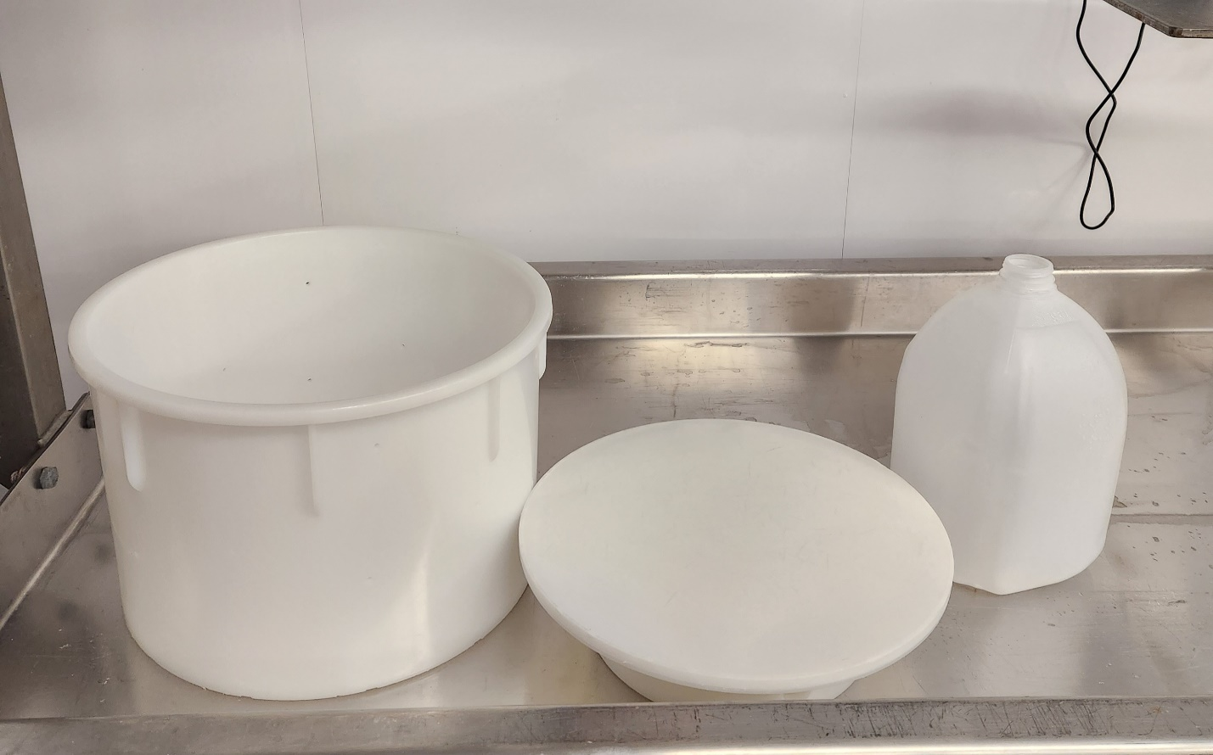

28 lb Kadova with screen
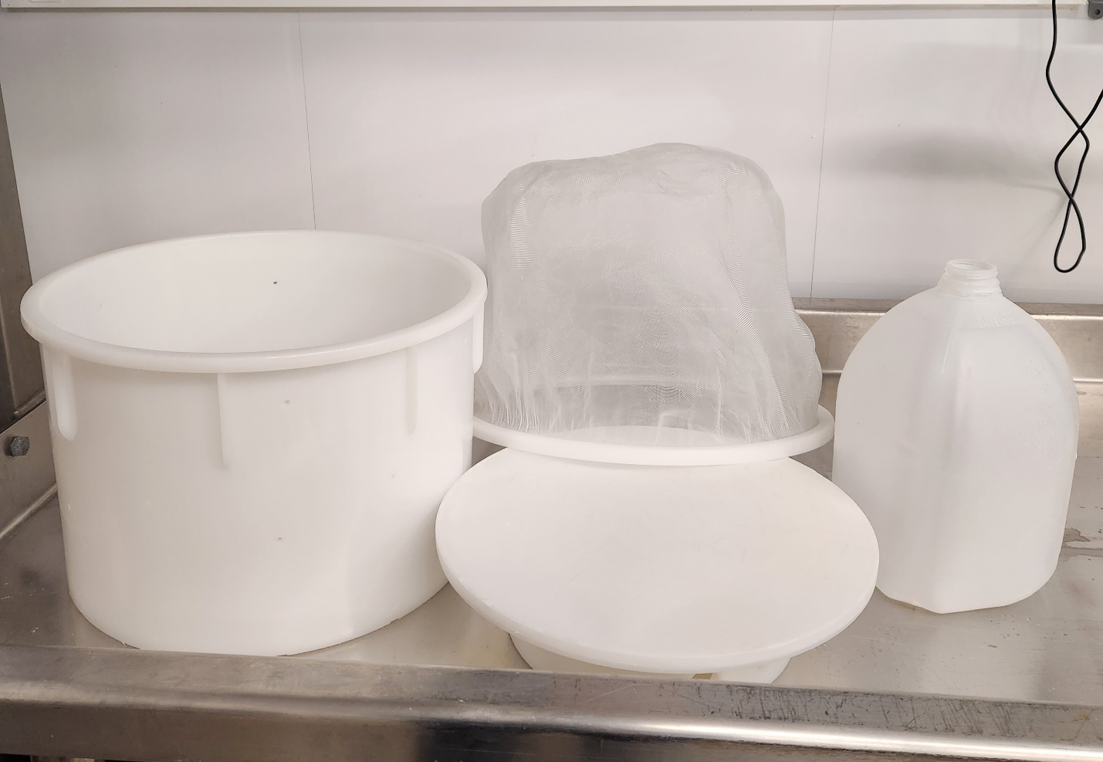

Loaf Kadova
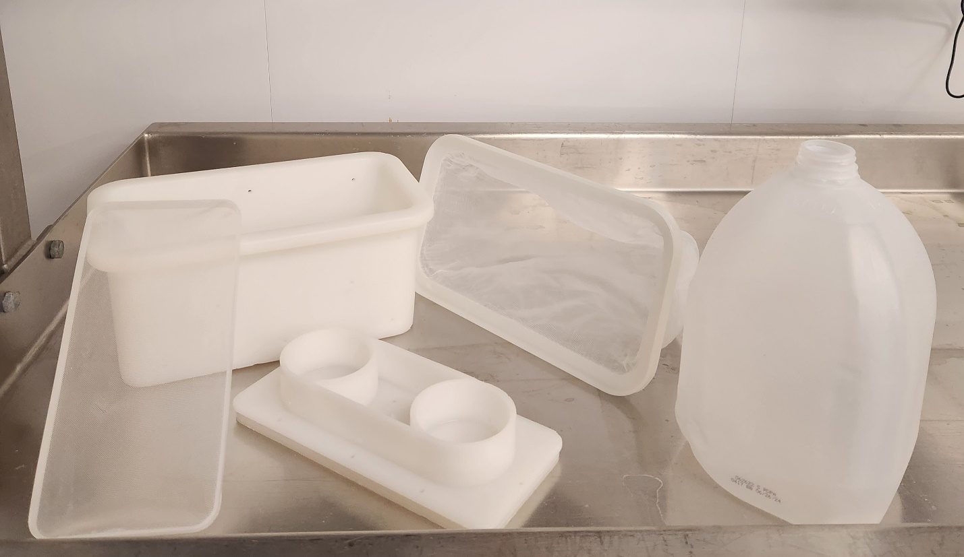

8” cheese mold with follower
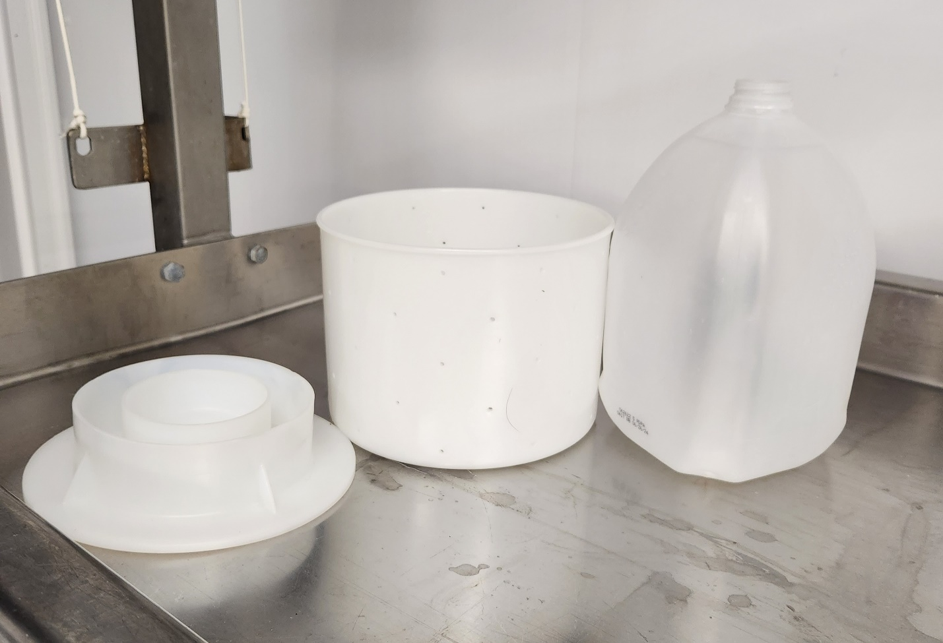

5” diameter with follower (short)
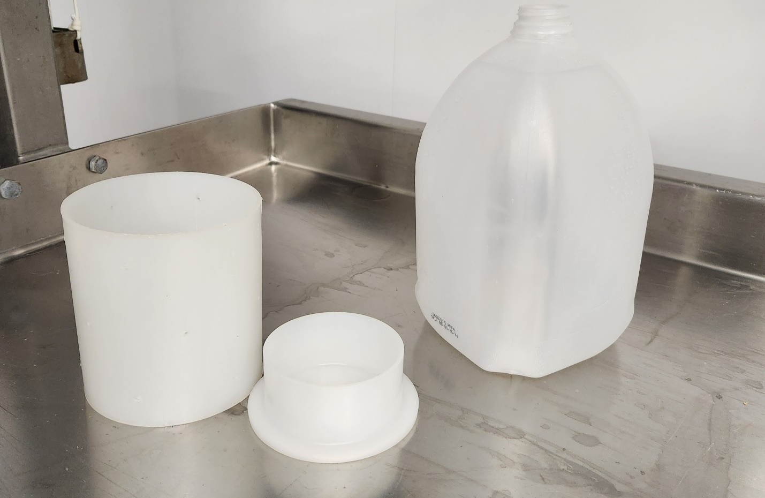

5” diameter (tall)
